The effects of time dilation in space applications

[Company name] | [Company address]

Final year project

Timi ogunmakin

2016

Contents

Best methodological practices in developing applications 2

Researching the effects of gravitational time dilation and their formulas 4

Researching the depth of using realistic physics in comparison to simulating physics 5

The most suitable tools in calculating during application execution, based on performance on frames per second and minimal effect on hardware as well as observational advantages 6

The adoption of live data from trusted sources for planetary data 7

References 8

# Best methodological practices in developing applications

Methodologies are a way of structuring, planning and controlling the process of developing for an efficient way in producing software. There are multiple different methodologies which help in controlling the process, it is up to each individual to choose which methodology to select. The task at hand is an influential factor in the selection process of a methodology as a certain software solution may be more compatible with a certain methodology, for example if a solution is to be regularly updated after provided to its client then it would not be beneficial to use a waterfall methodology as it has a very rigid process, however feature driven development would be preferred as it allows the use of adding features incrementally.

There are many advantages to using software engineering methodologies. One of which is since significant effort is put into recording and analysing customers’ needs and producing a requirements document, the chances of large requirement changes should be minimal during a phased delivery which increases confidence that each delivery will be on time. Another advantage is the developers always know where they are going. Developers are not left to just start coding in some direction based upon a feature request card. A functional specification document is produced as well as pseudocode which is used to design the software. The hard and tricky part are completed first. After this, it is relatively easy and straight forwards to code. Producing a requirement document, specification document, a design document in pseudo code / diagram gives the developer ample opportunity to think about the code and design the code well from the start.

There are multiple different unique ways to structure the process of the development life-cycle, there are no right or wrong life-cycles, and each process is made to accommodate unique software solutions. It is up to the developer of the software to select which process suits more and feels will reach the target solution is the most efficient and reliable way.

Out of all the software engineering methodologies, there are three closest to which may help to complete the project, which are the agile methodology, spiral methodology and the waterfall methodology.

The agile methodology allows the ability to revisit the “phases” of development which improves project efficiency. The idea of revisiting phases over and over is called “incremental and iterative development”. The development lifecycle is cut up into increments and each iteration focuses on each of the traditional phases of development (ones of which waterfall would have). For example the requirements is an ongoing process that is changed and altered continuously, as new requirements surface and as the scope of the project changes, the processes continually capture the requirements iteration after iteration.

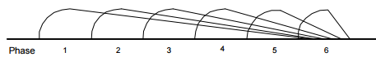

The spiral methodology allows focus on risk assessment and on minimizing project risk by breaking a project into smaller segments and providing more ease of change during the development process as well as providing the opportunity to evaluate risks and weigh consideration of project continuation throughout the life cycle. “Each cycle involves a progression through the same sequence of steps, for each portion of the product and for each of its levels of elaboration, from an overall concept-of-operation document down to the coding of each individual program.” (Boehm, 1986). Each trip around the spiral traverses four basic quadrants.

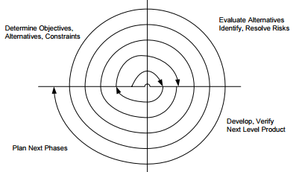

The advantages of using spiral methodology is that it allows the incorporation of waterfall, prototyping and incremental methodologies as a special case and provides guidance as to which combination of the models best fits a given software iteration, based upon the type of project risk. For example, a project with low risk of not meeting user requirements, built high risk of missing budget or schedule targets would essentially follow a linear waterfall.

The waterfall methodology allows the project to be divided into sequential phases, with some overlap, its focus is on planning, time schedules, target dates, budgets and implantation of an entire system at one time. It is tightly controlled over the life of the project through the use of extensive written documentation as well as formal reviews and approval by the user at the end of most phases before beginning the next phase.

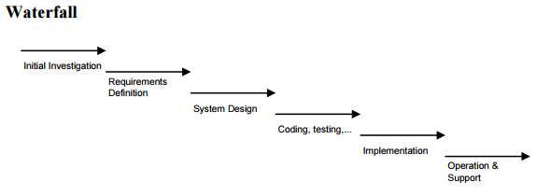

The advantage of using a waterfall methodology is that this is a simple methodological process to follow which allows in-experienced teams and project managers to work with easily as compared to other methodologies when team sizes fluctuate a lot. The orderly sequence of development steps and strict controls for ensuring the adequacy of documentation and design reviews also helps ensure the quality, reliability and maintainability of the developed software.

|  |  |  |  |  |  |
| --- | --- | --- | --- | --- | --- |
|  | Suitability | Ease | Refactoring | Documentation | Total |
| Agile | 100 | 70 | 100 | 40 | 310 |
| Spiral | 70 | 70 | 70 | 50 | 260 |
| Waterfall | 60 | 85 | 10 | 100 | 155 |

After creating the decision matrix, the selected methodology for developing the application will be the agile methodology, due to the fact that agile is more suitable than the spiral and waterfall methodologies because agile allows the ability to manage the development of the application iteratively and incrementally which is perfect as it will allow the ability to keep adding more content into the application as the process goes on reducing the risk of failing to implement everything at once. Although waterfall is easier than spiral and agile, waterfalls rigidness in staying to a specific stage may become a problem if important and new problems arise which would result in changing some plans, waterfall does not allow this so agile is preferred. Because Agile allows refactoring, it is ranked 100 as it allows the ability to change plans at start and incrementally make improvement and changes to the application, whereas waterfall does not allow the ability to go back to previous stages. Spiral allows the ability to go back however it is not done incrementally.

# Researching the effects of gravitational time dilation and their formulas

What time dilation is

Different types of time dilation (relative space / gravitational time dilation)

How it affects us (also what applications rely on time dilation i.e. GPS devices etc)

Physics formula for calculating gravitational time dilation

# Researching the depth of using realistic physics in comparison to simulating physics

Different ways of calculating gravitational time dilation

# The most suitable tools in calculating during application execution, based on performance on frames per second and minimal effect on hardware as well as observational advantages

Languages used

Renderer used

Math libraries used

Visual studio performance monitor to compare both calculations

# The adoption of live data from trusted sources for planetary data

# References